Vpc ,Ec2, Elastic load balancer and Auto scaling

**VPC**

**What is vpc**

Amazon Virtual Private Cloud (Amazon **VPC**) lets you provision a logically isolated section of the **AWS** Cloud where you can launch **AWS** resources in a virtual network that you define. ... You can use both IPv4 and IPv6 in your **VPC** for secure and easy access to resources and applications.

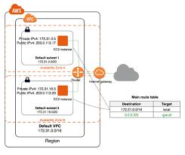

* Subnets.
* Elastic network interfaces.
* Route tables.
* Internet gateways.
* Elastic IP addresses.
* VPC endpoints.
* NAT.
* VPC peering.

**Creating vpc**

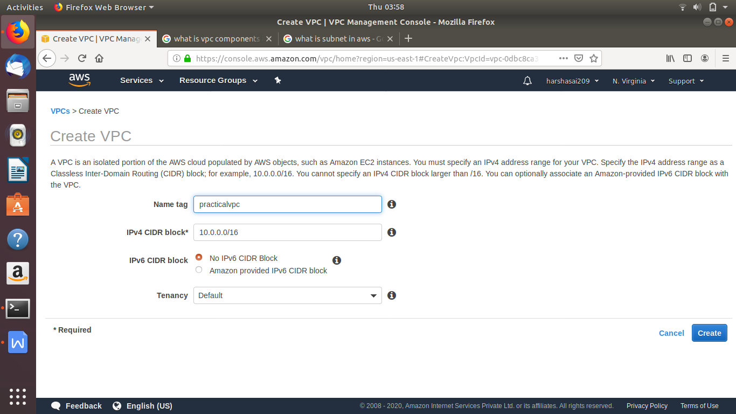

**Now successfully vpc created**

**Now creating subnets for differnet availablity zones**

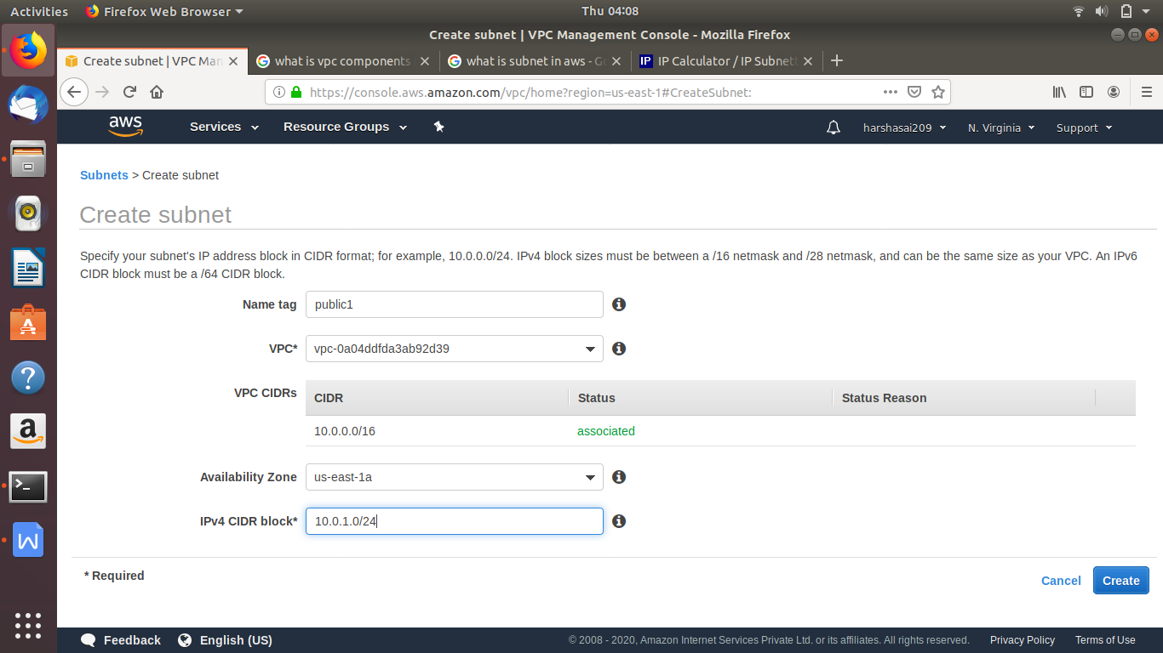

**Now creating another subnet**

**Now creating igw**

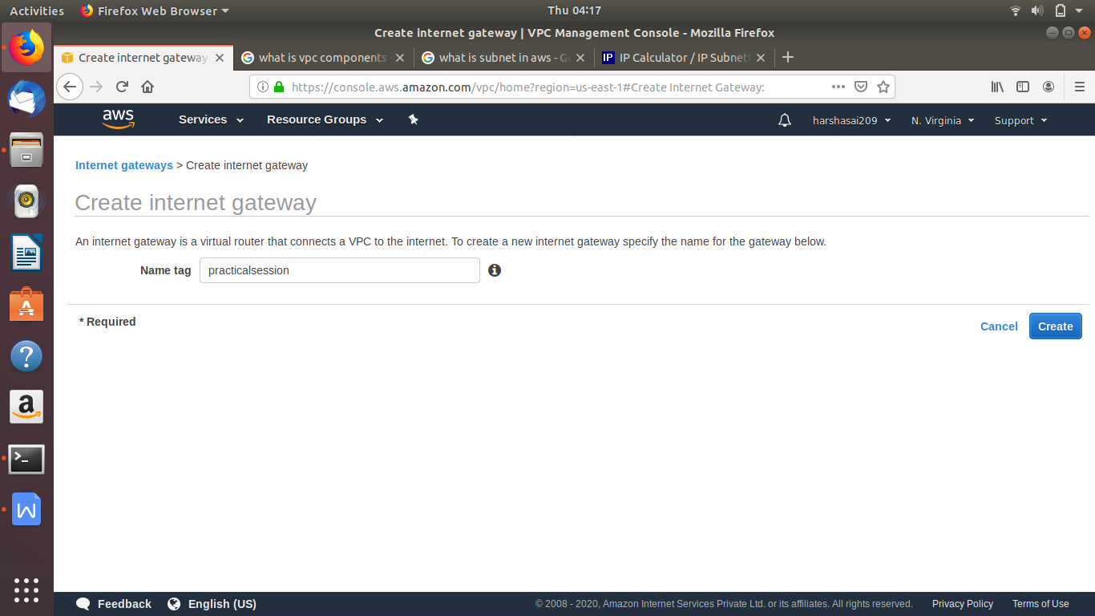

**Now internet gateway is created**

**Now we have to attach to new vp**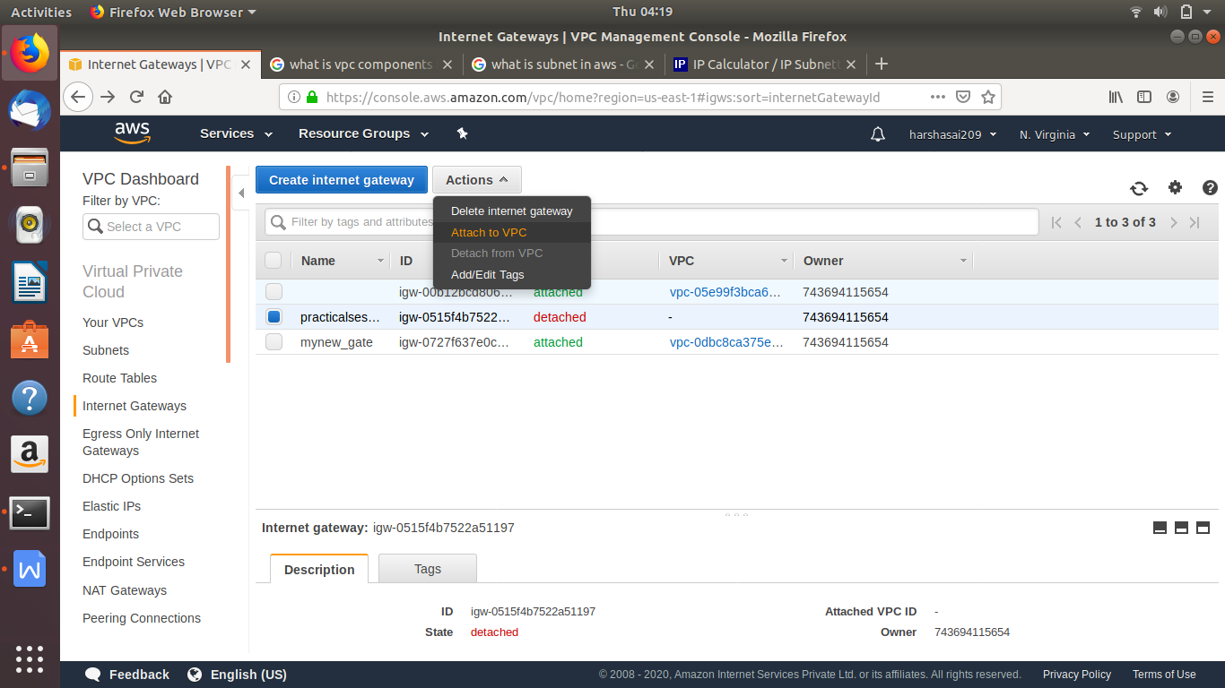

**While creating a vpc there is default route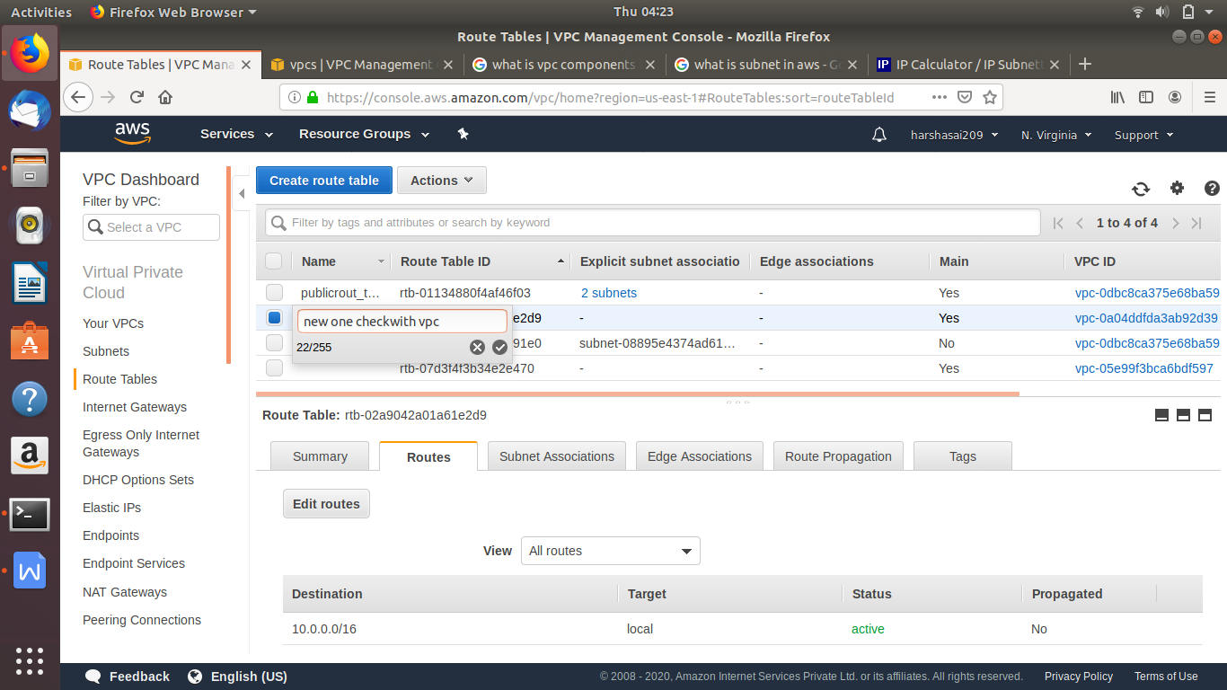 table is created**

**Option yes will appeared**

**We have to attach subnets to route table which are going to public subnet**

**For route table adding igw (internet gate way)**

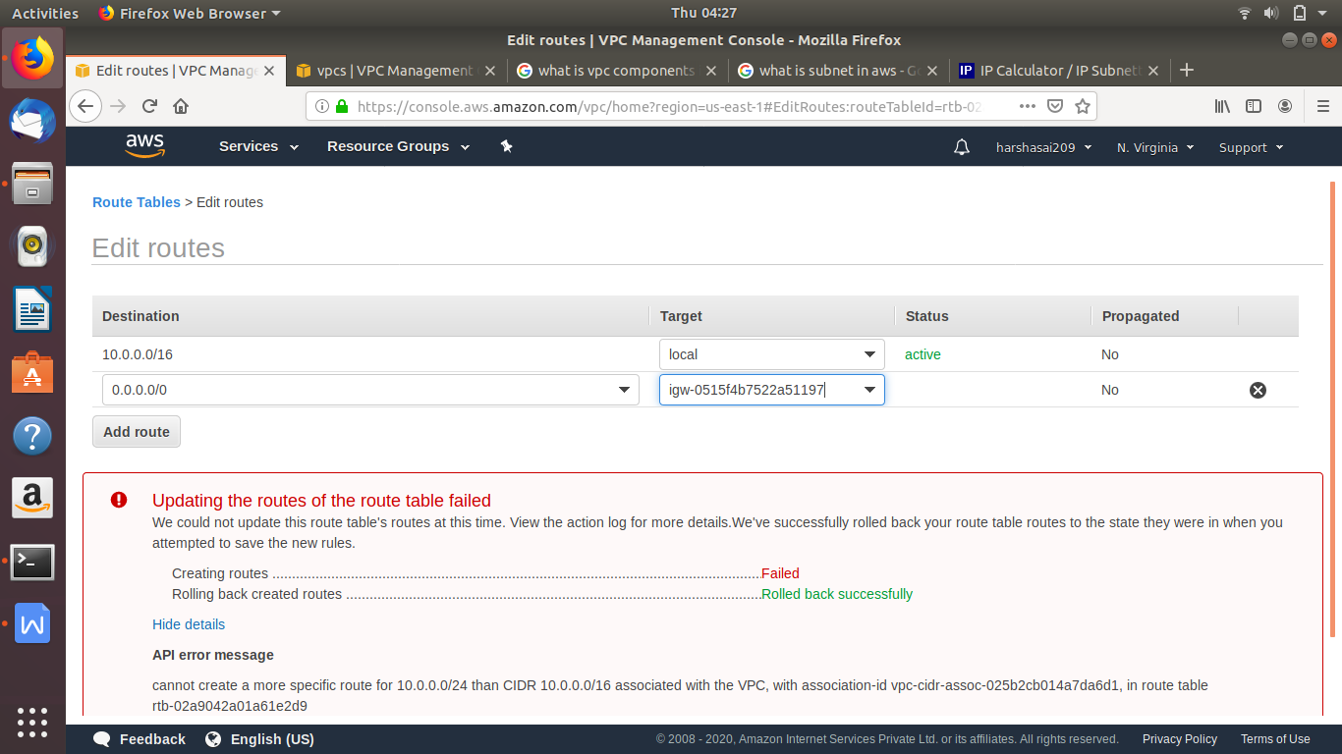

**Adding required subnets to igw route table**

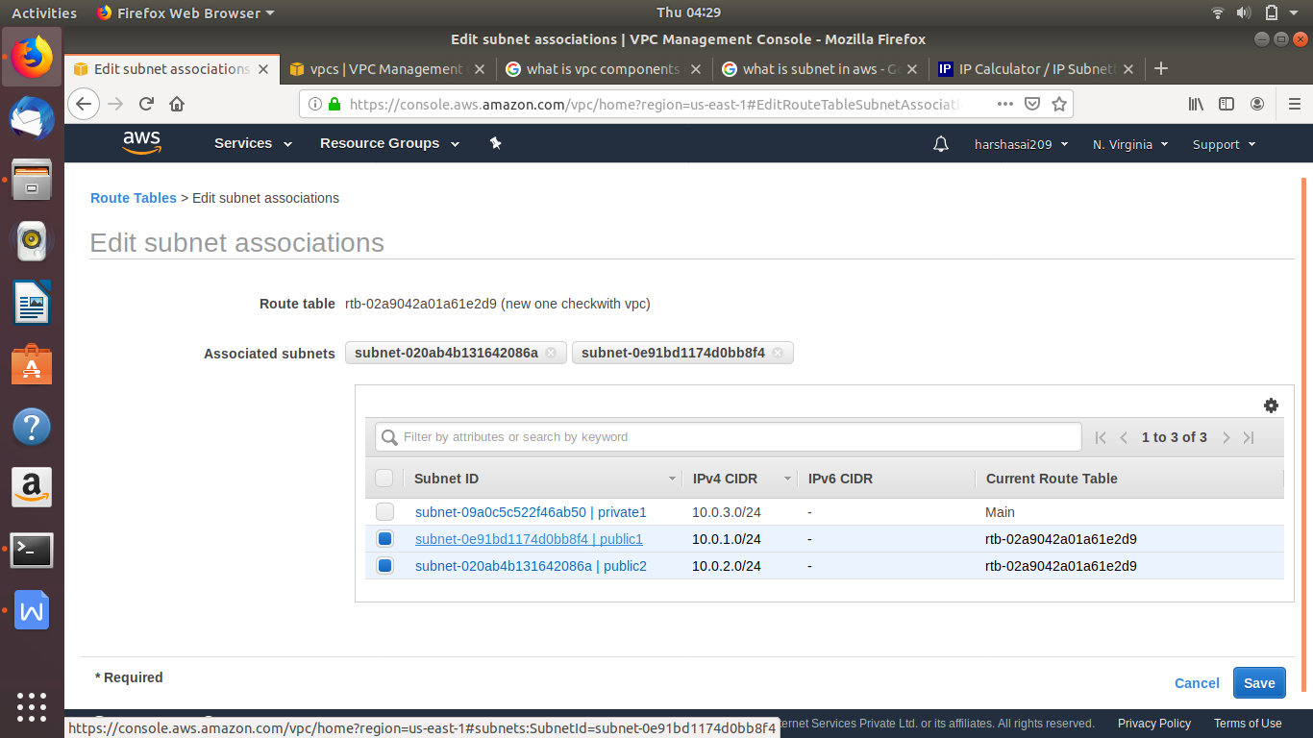

**Now creating a route table for private subnets for routing**

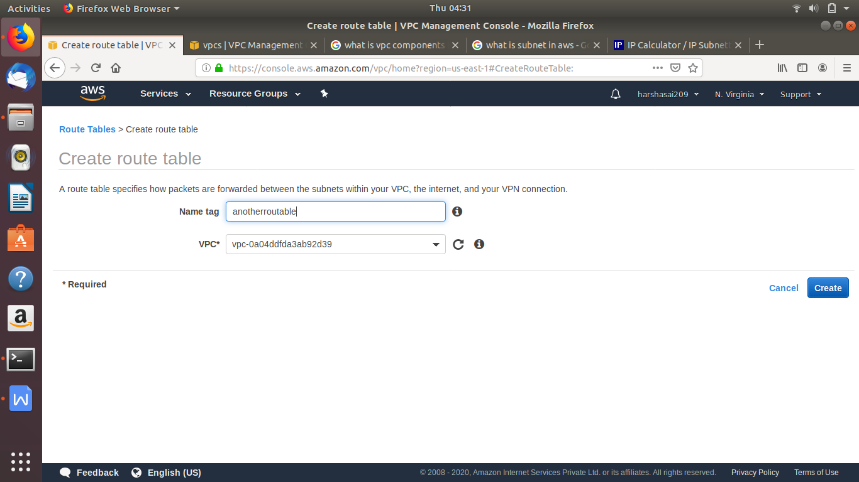

**Now required private sub-net is added another rout table**

**Now create a ec2 in public sub net with respect its availability zones**

**While creating load balance we required two instance which are in different availability zones**

**Now creating two ec2 instance with two different subnets which are in different availability zones**

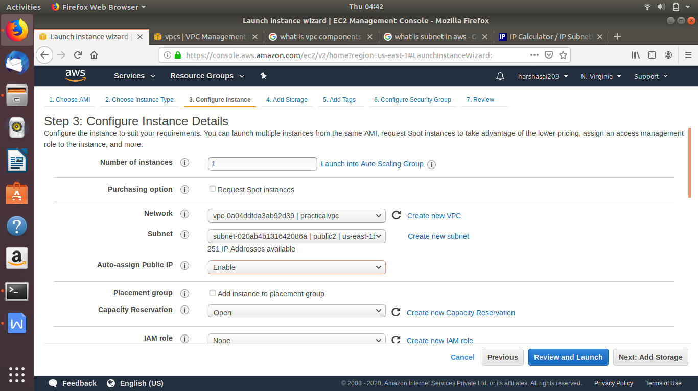

**Taking two instance which are in different availablity zones**

**now each instance installed with apache2**

**And now content of index.html is change to hi world in both cases**

**First case hi world1**

**In second instance hi world 2**

**Now creating load balancer**

**Select load balance option**

**Now here selecting application load balance**

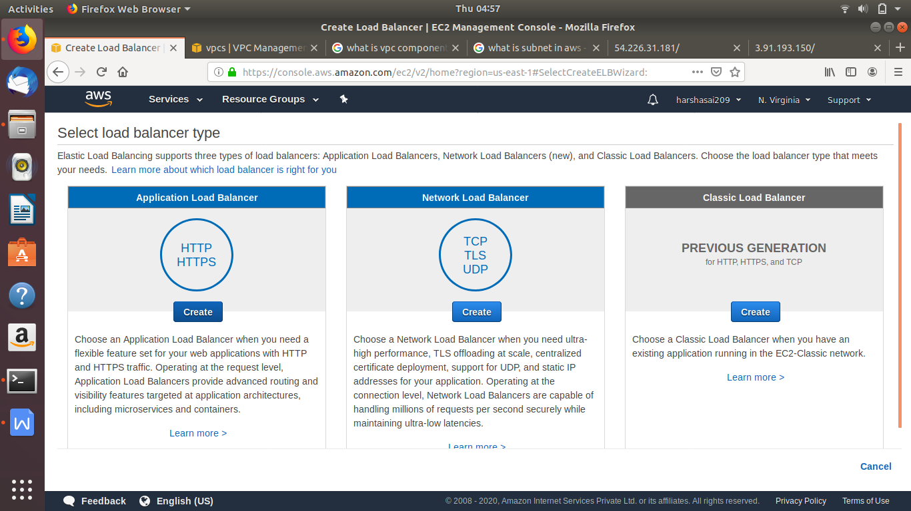

**Next step**

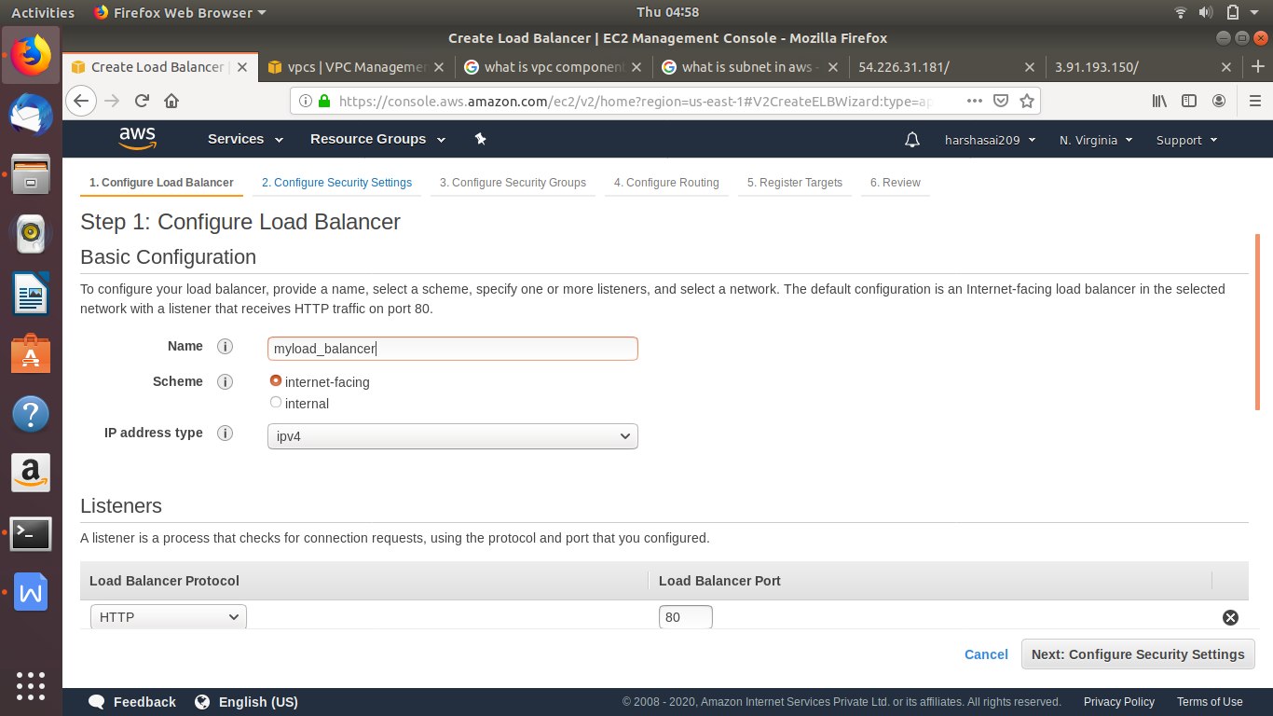

**Now go to advance settings**

**Select two subnets which are in different zones**

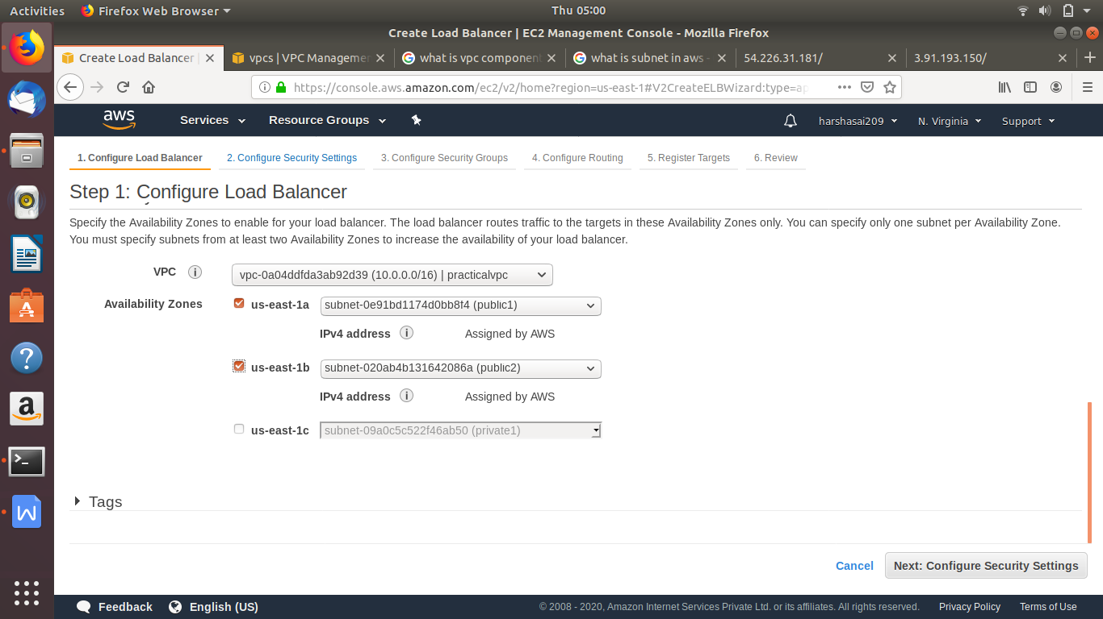

**Security groups**

**For load balance**

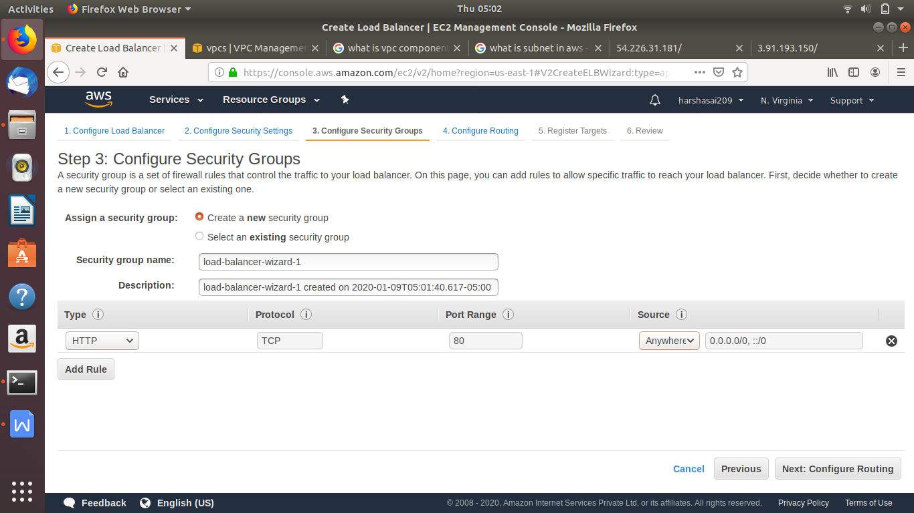

**Now creating a target group**

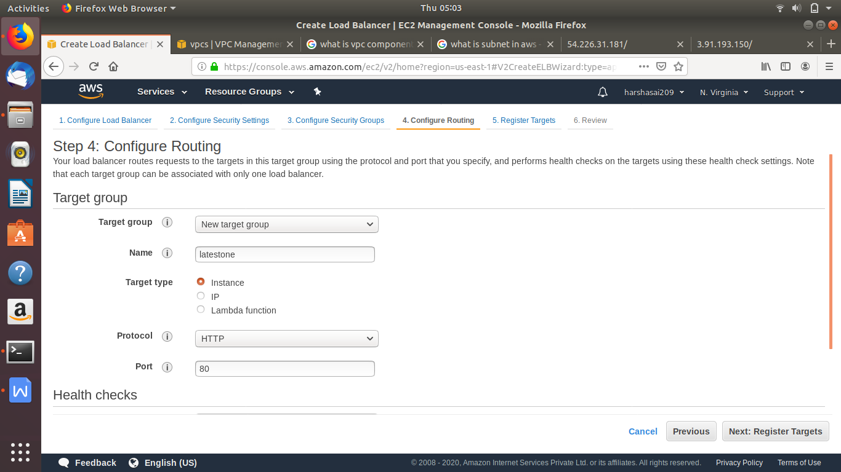

**Now give path of index.html path**

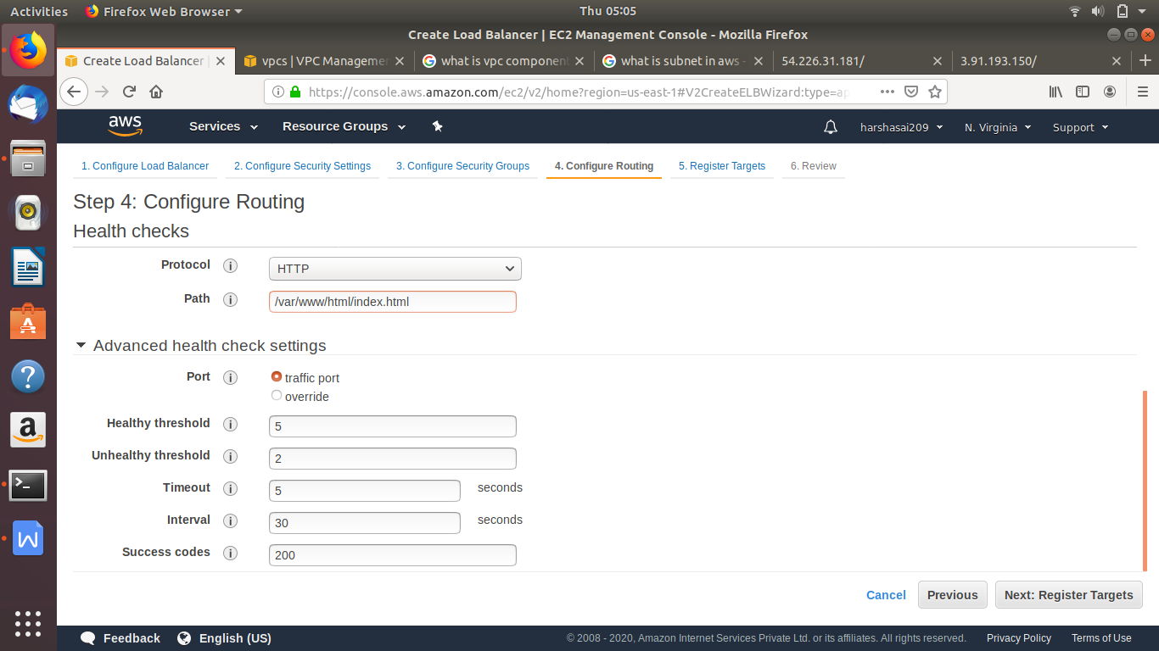

**In registry targets**

**Adding these instance which are availble in subnets**

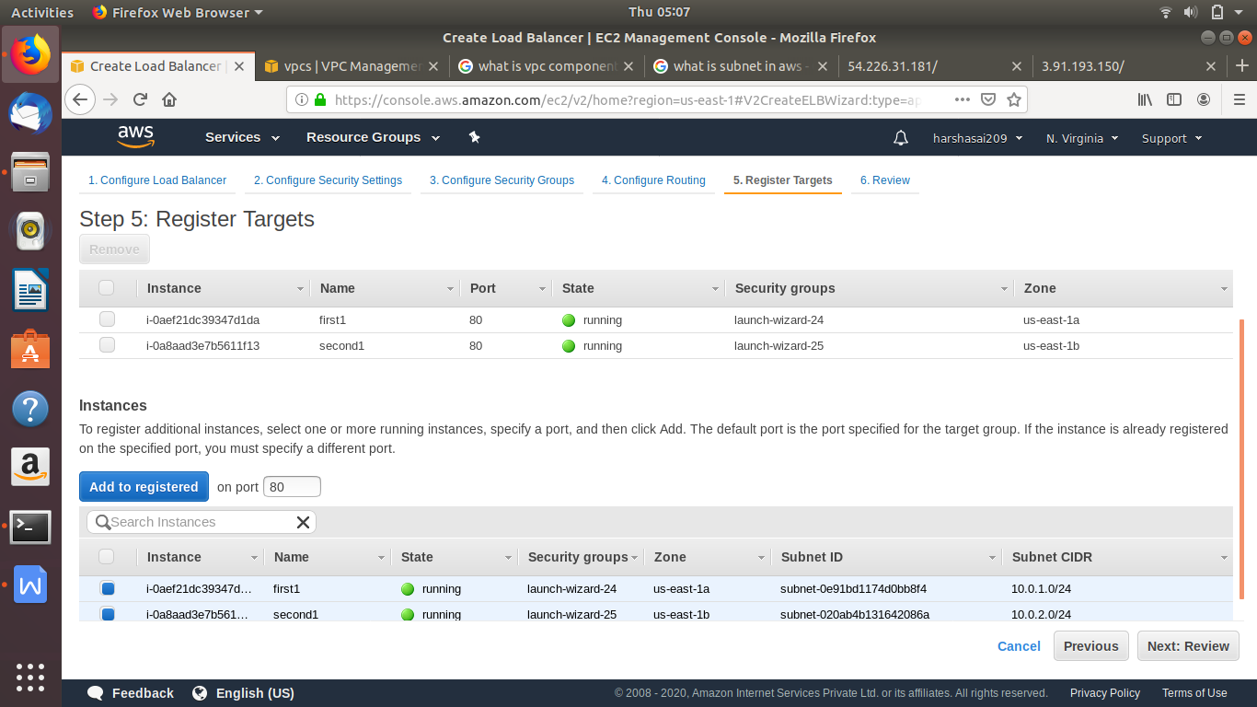

**Now load balancer is created**

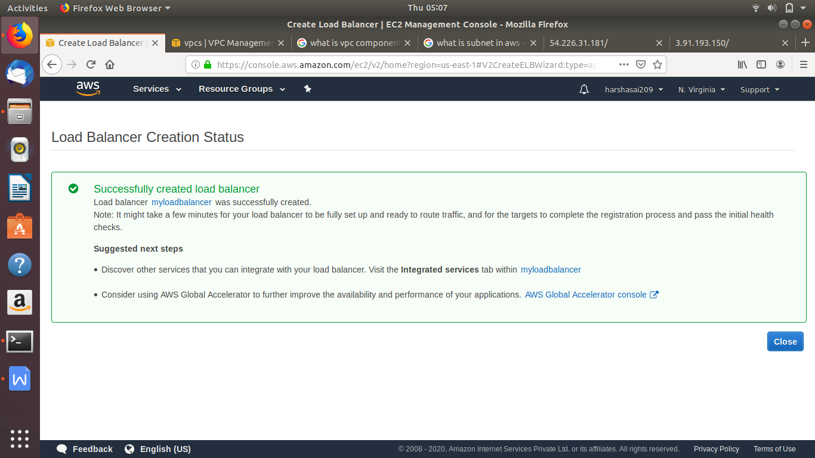

**Wait for some time until load balance up**

**Copy domain name and paste it web browser**

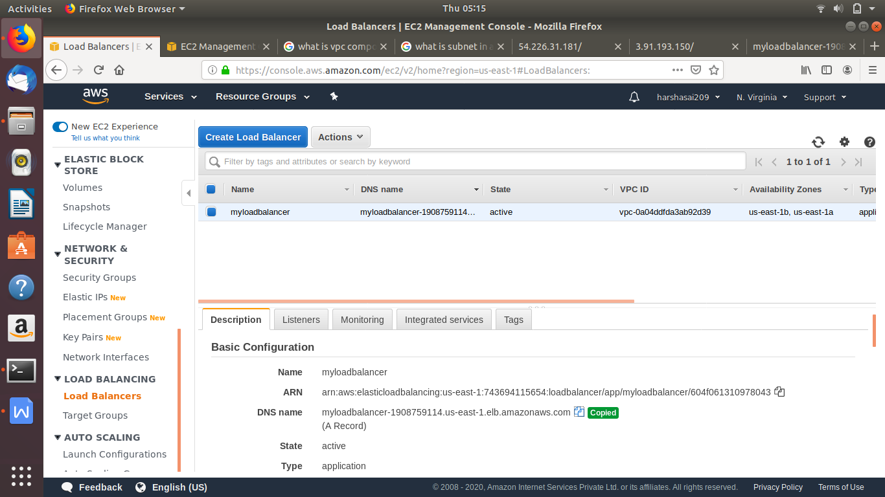

**Now output will be get from two instance when hitting that ip of load balance (wait for 3-4 mins)**

**Checked successfully**

**Now creating Auto scaling for above these instances**

**Go to instance attaching those instance to autoscaling**

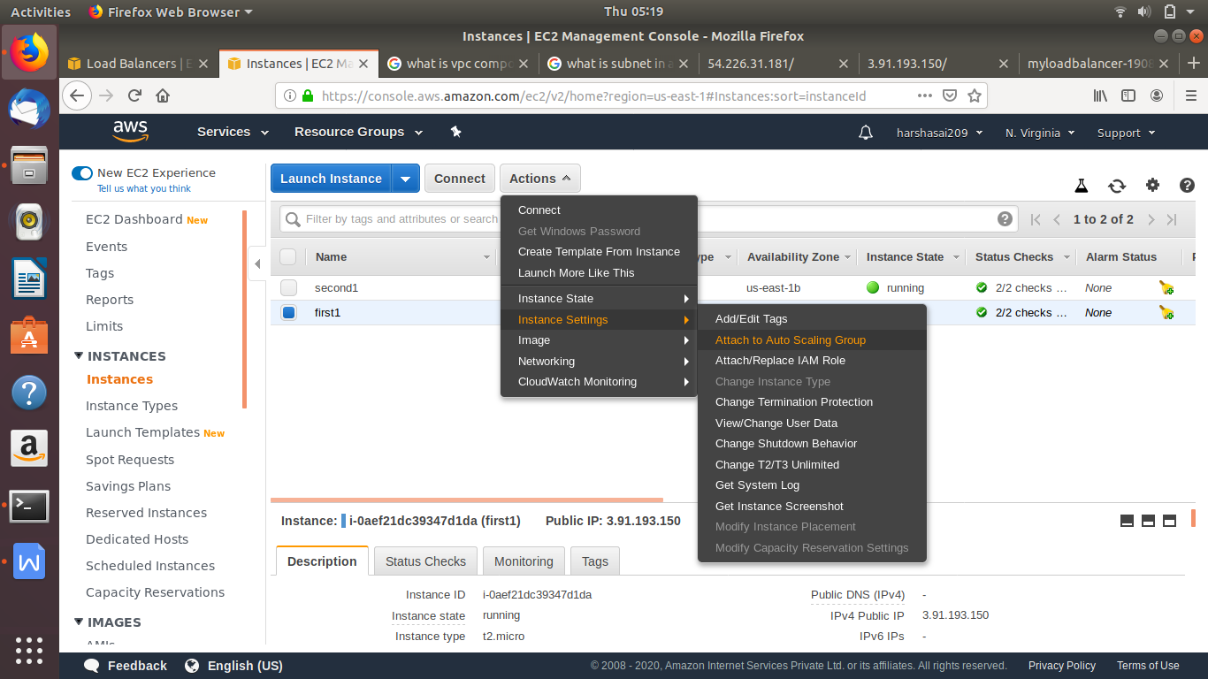

**Now attaching instance to new auto scaling** 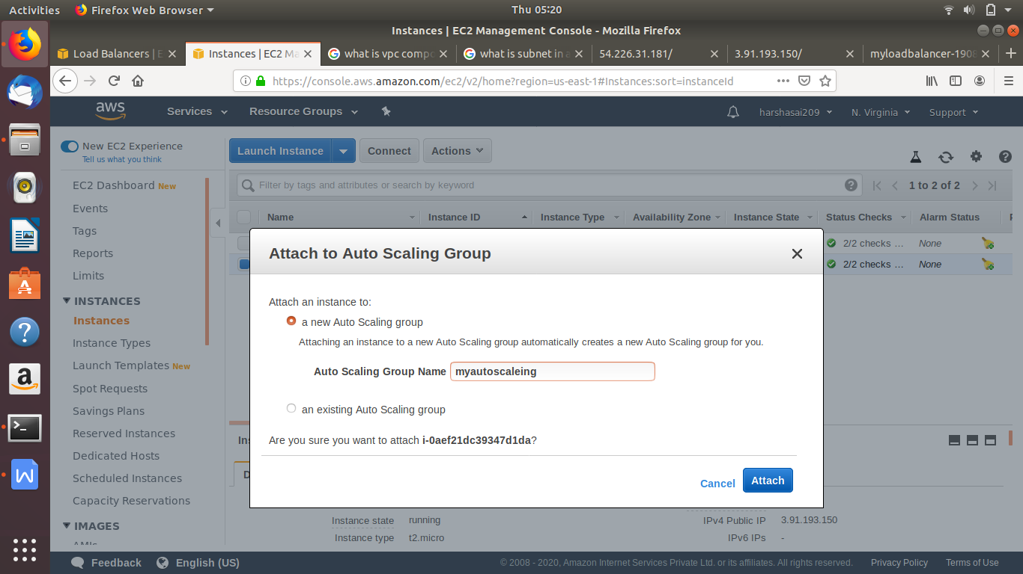

**Now to auto scaling created group change maximum limit of instance**

**Go to auto scaling group change the maximum size**

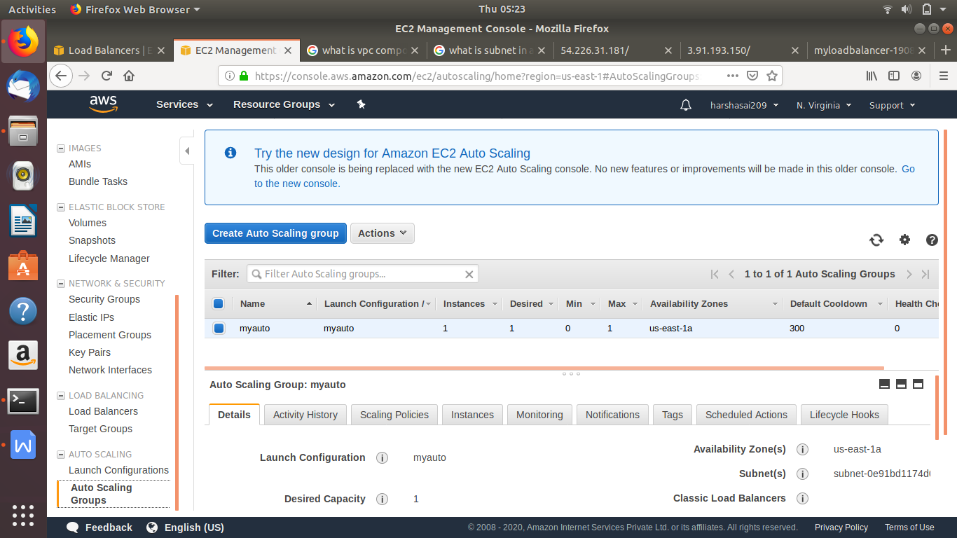

**Change to limit 4 -5 according required**

**And also give the name of load balance group name**

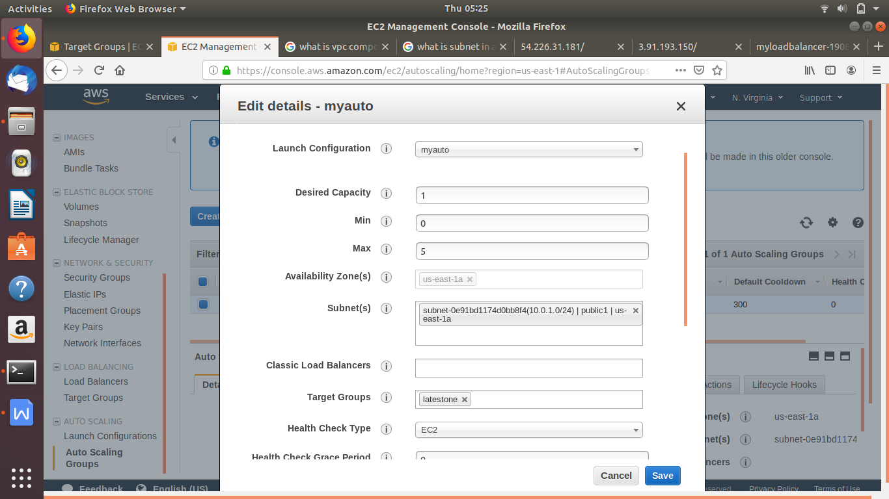

**Adding two subnets also for attaching instance it says one instance is occupied with one availblity zone so we need two availblity zone**

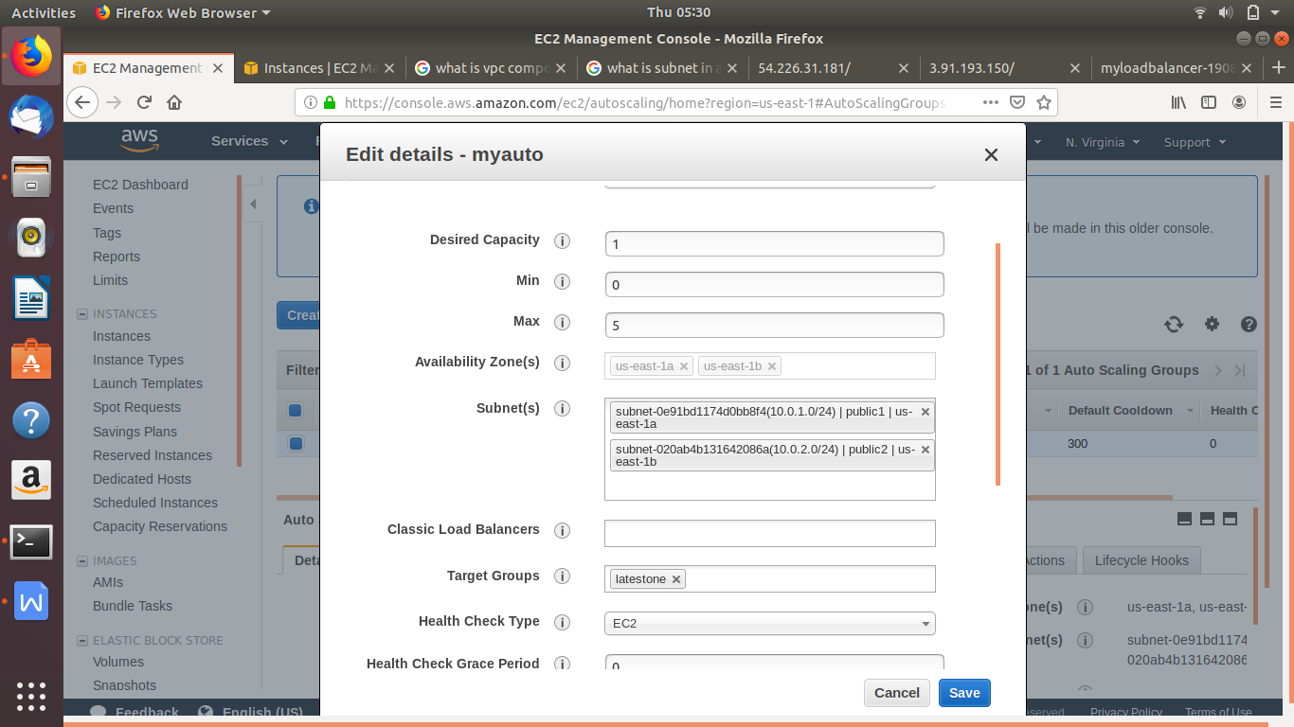

**Manually instance stopped and created instance** 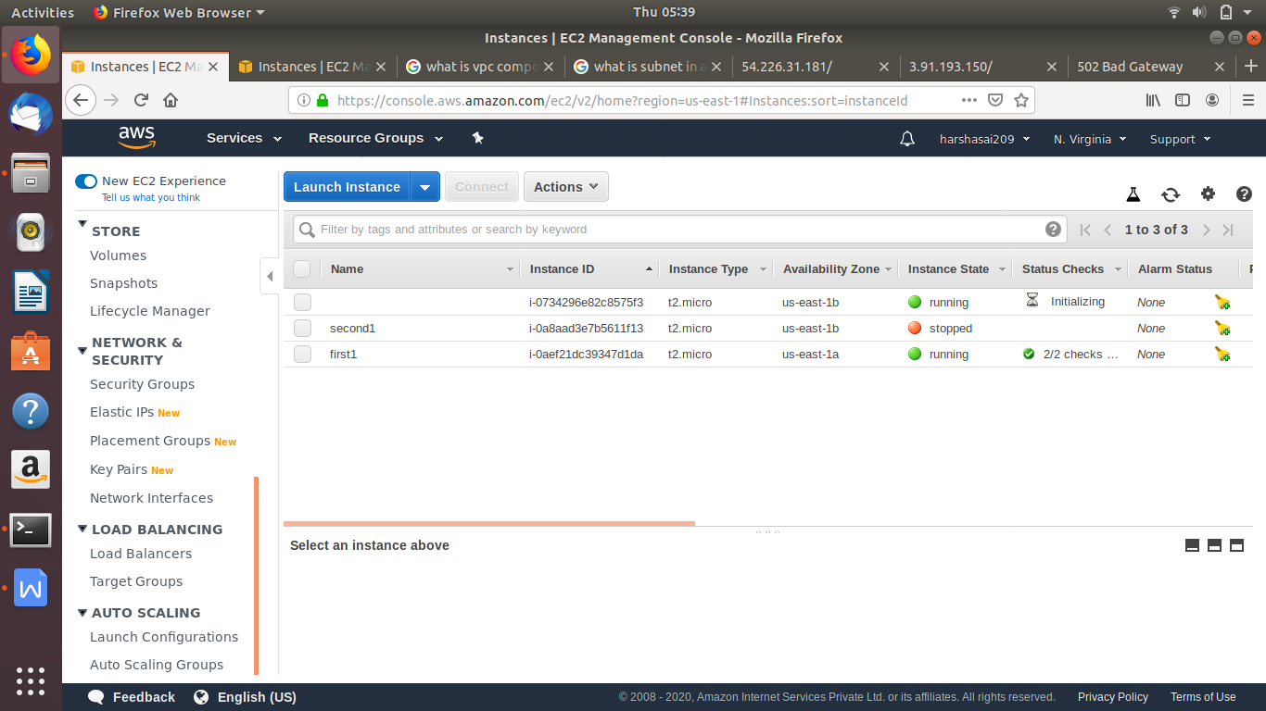

**Created a new one**

**Checked it**

**Launch temple which is used to create a Ami**

**With respect required applications and services**